12th May 2016

**School Children visit YOKOHAMA Tyre Test Center of Nürburgring**

As part of its community involvement and support to the German “Girls & Boys” programme, YOKOHAMA Europe invited some students for a day at the YOKOHAMA Test Center of Nürburgring.

Throughout the day, there were numerous activities and explanations given to the participants on general and technical information about Tyres, performance, test driving and the extensive development that takes place before production of a car tyre.

With an extensive experience of supply to OEM’s YOKOHAMA has established a solid reputation among the top car manufacturers in the world and the children were also able to see some of the superb cars used for testing.

Additionally YOKOHAMA Europe specialists at the centre, including Thorsten Theiss, senior manager of Tyre Testing at YOKOHAMA Europe, briefed them on their job roles as well as providing an insight into the Japanese Tyre manufacturer’s company and history. The school children were also able to tour the facilities at the centre as well as the paddock at the Nürburgring.

The visit formed part of the Girls & Boys programme which is supported by several German Government Educational and Family institutions as well as private enterprise and which sets to give school children guidance and some orientation on jobs for their future careers.

More information on the programme is available in German on: [www.boys-day.de](http://www.boys-day.de)

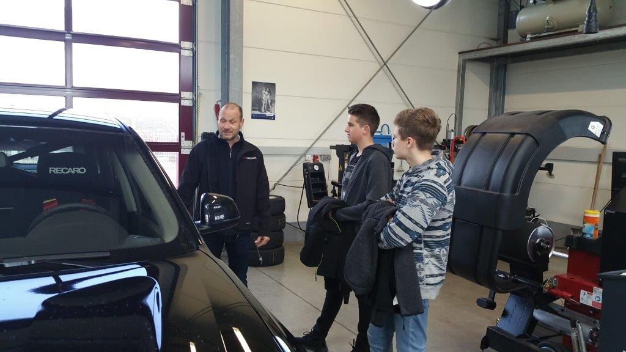

*YOKOHAMA Europe Senior Manager Thorsten Theiss and students at YOKOHAMA Tyre Test Center Nürburgring*

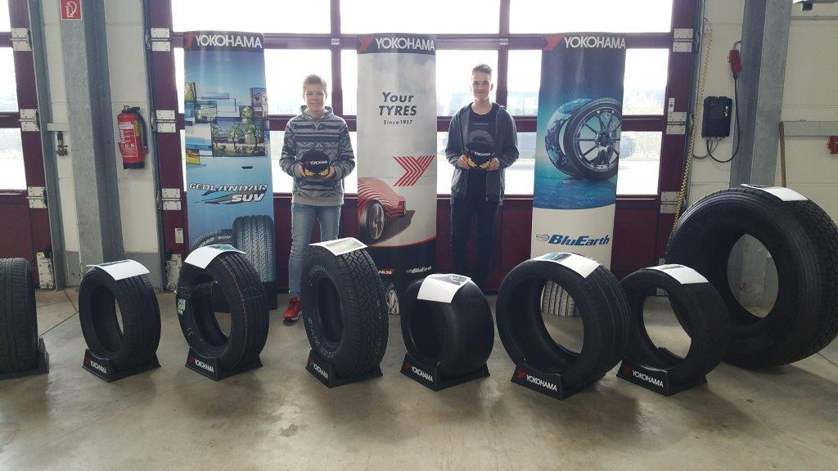

*Students Ben Strabel and Luca Fink at the YOKOHAMA Tyre Test Center of Nürburgring*

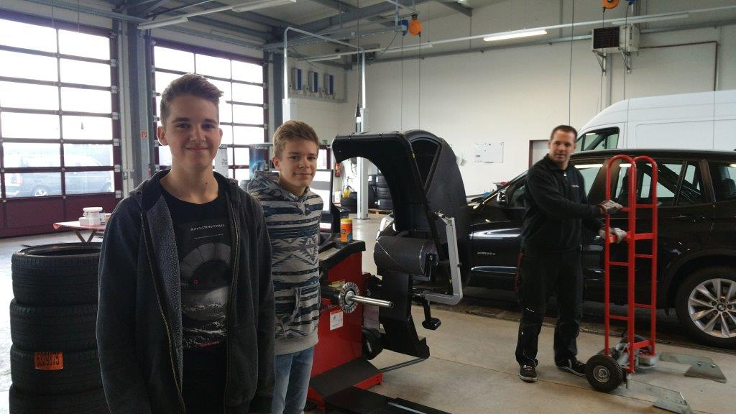

*Students visiting Facilities*